John Ace
Magic with and Edge

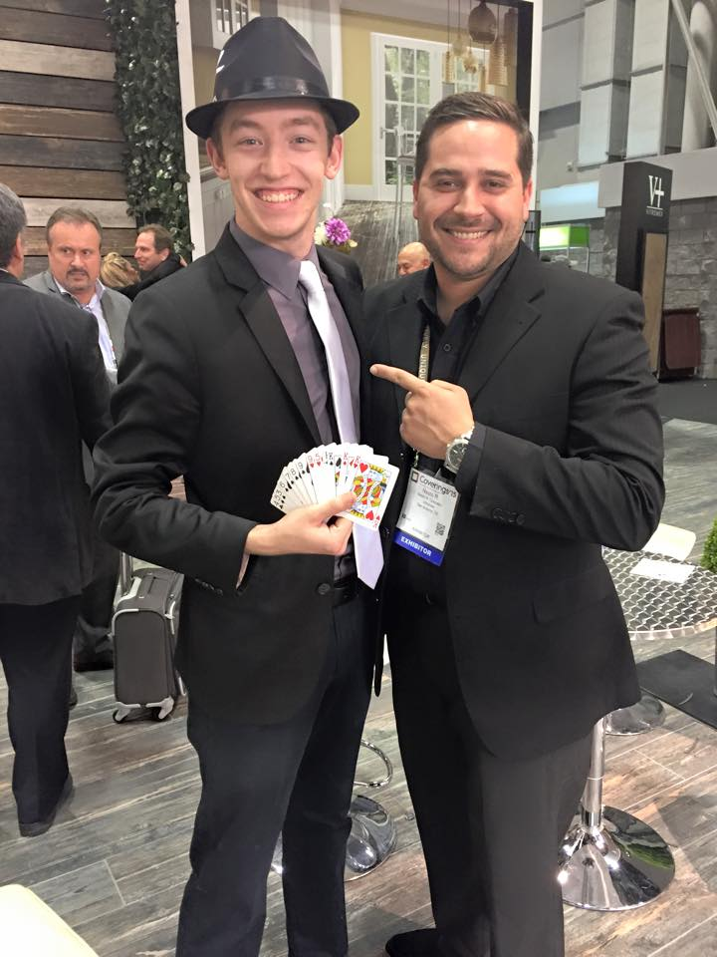
Straight from the number one tourist destination in the world, John Ace will bring his street-style magic to your event. This corporate friendly clean-cut magician has performed for celebrities like Tiger Woods and his family, and for corporate events for Fortune 500 companies at Hard Rock Live, House of Blues, and other venues across Florida. John Ace can handle any audience from kids to corporate.

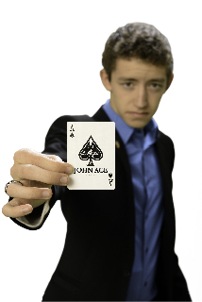
The combination of Traditional and hip Street Magic will mystify your guests and leave them wondering if they just saw an illusion or real magic! In the style of Criss Angel and David Blaine, John Ace will perform magical illusions with an edge. This 21-year old is beyond his years in his ability to manipulate your mind and eye as he performs close-up sleight of hand illusions and mystifying mind reading exercises. John Ace will literally freak your guests out with a collection of illusions using coins, money, cards, and much more.

John Ace can mingle with your guests for corporate receptions, or book his STAGE SHOW with his beautiful assistant!

